A Plan For Senior Care’s Guide To
Music Therapy For The Mind

Recent findings have proven that the correlation between memory and music enhance the lives of our senior loved ones. Use our guide to learn more about this important tool for the mind and how it can help your loved one thrive.
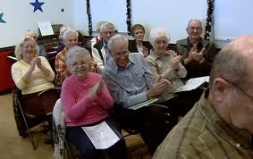

- Researchers have determined that music therapy helps to treat Alzheimer’s and slow the process of different stages of dementia.

- Music therapy is a helpful tool when working with memory and communication skills. Listening to music, whether live or recorded, helps your senior loved one engage in activity and be less secluded.

- Some positive effects of music therapy include memory recollection, enhanced emotions, and moods, pain management, the opportunity to become socially involved with others and create a calming environment.

- Music has the ability to help your loved one sustain a quality life and even possibly enhance it.

- Episodic memory refers to memories of past personal experiences that took place at particular time and place. Specific songs and music can help jog those memories.

- Music therapy can be applied at all stages of a senior’s life.

- To learn more about music therapy, reach out to your local senior center, day care or useful websites such as www.musictherapy.org

If your loved one is struggling at home to care for her/himself and you would like to explore senior care and housing options, please give us a call today. We will be happy to create a personalized care plan for your loved one.

www.APlanForSeniorCare.com Call Us Today (866) 657-0026 info@aplanforseniorcare.com

