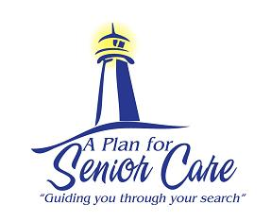
A Plan For Senior Care’s Guide
On Dehydration With Seniors

Dehydration in seniors is a common yet serious condition that can be life-threatening. Dehydration is one of the most common reasons for hospitalizations in people over 65 years old. Seniors are at a higher risk for dehydration. A few reasons are their age, health conditions, inability to recognize thirst and medications they are taking. This health condition can mimic the symptoms of dementia and Alzheimer and often goes undetected until the senior is in need of medical attention.

It is important to know the signs of dehydration. Not all signs are needed to be dehydrated. The most common signs are;
• Sudden and persistent fatigue, weakness or both
• Headaches, dizziness, nausea or vomiting
• Sudden acute forgetfulness or confusion
• Rapid breathing or increased heart rate
• Concentrated urine
• Loose skin with dryness or dryness of nose and mouth
• Constipation
• Loss of appetite
• Sunken eyes or decreased tears

Healthy seniors should drink 6-8 glasses of liquid a day. Below are some ways to help avoid dehydration.
• Knowing which medications cause fluid loss
• Avoid caffeinated and alcoholic beverages which cause dehydration
• Drink fluids with all snacks and meals
• Use a straw to drink so more fluids are easily consumed
• Eat broth based soups, fruit and vegetables that have a high water content
• Have a bottled water with the senior at all times
• Keep an intake log of how much fluid is being consumed and how often the senior is urinating
These are some general guidelines to assist you with your knowledge of dehydration. Call your physician immediately if you suspect or are unsure if your senior is dehydrated.

If your loved one is struggling at home to care for her/himself and you would like to explore senior care and housing options, please give us a call today. A Plan For Senior Care will be happy to create a personalized care plan for your loved one.

www.APlanForSeniorCare.com Call Us Today (866) 657-0026 info@aplanforseniorcare.com

