A Plan For Senior Care’s Guide On
Safe Senior Driving

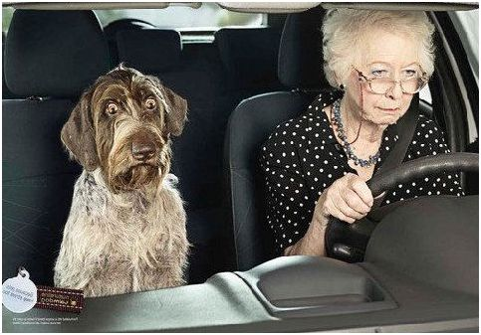
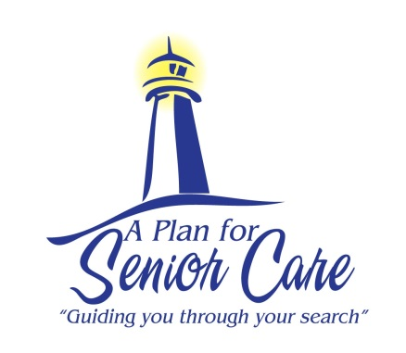
Many seniors become worried when it is time to renew their Driver’s License. Often there is anxiety over passing the test and concern over losing their license. Below is a guide to help your loved one prepare for the renewal of their Driver’s License.
- Talk to your loved one about their concerns and anxieties in preparing for the Driver’s License test.
- Encourage your loved one to visit their eye doctor to ensure that their prescription is correct and up to date.
- Share with your loved one the DMV website, www.dmv.ca.gov. It has many great tools to help seniors be prepared for the test, such as sample written tests, the California Driver Handbook and the Driving Knowledge Tutorial.
- Make sure your loved one is aware of the new laws about cell phones and texting.
- Schedule your loved one’s appointment early enough in the day, so there is enough time to take the written and vision tests. The DMV will not administer exams after 4:30 pm.
- Remind your loved one that the DMV wants them to pass the test.
On the other hand, your family or your loved one may be thinking that driving has become more of a challenge and safety is a concern. Giving up the keys is a process for every senior. Below is a guide to help you get through this difficult time.
- At the onset of physical and mental changes, bring to your loved one's attention to what you have observed.
- Let your loved one know that you value their ability to care for themselves, but share your concern for their safety and the safety of others.
- When changes become clearer, consult professionals for assessing your loved one. AAA offers an initial assessment of skills needed for safe driving. If needed, a doctor can suggest to your loved one that it is time to stop driving and will notify the DMV.
- You can contact your loved one’s local DMV to request they review his or her driving qualifications:
You can write a letter identifying the driver who is causing the concern, giving specific reasons for making the report, and mail it to the local DMV Driver Safety Office. Alternatively, you can complete a form, Request for Driver Reexamination, and mail it or take it to one of the DMV locations listed on the form.
- When your loved one stops driving, there is an adjustment period. Let your loved one know that is important to you that they continue to have freedom and independence. There is a strong correlation between independence and happiness.
- Create a transportation plan that allows your loved one to continue to feel independent. AAA offers information at www.getting-around.org or check with your local senior center for transportation options in your area.

If your loved one is struggling at home to care for her/himself and you would like to explore senior care and housing options, please give us a call today. We will be happy to create a personalized care plan for your loved one.
www.APlanForSeniorCare.com Call Today (866) 657-0026 info@APlanForSeniorCare.com

