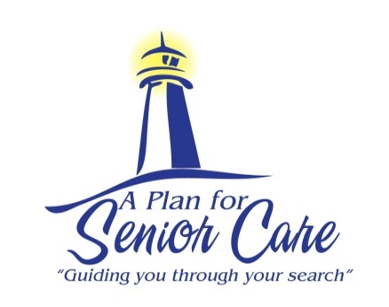

A Plan For Senior Care’s Guide On
Fall Prevention

Senior loved ones are precious and fragile. As one gets older, the risk of falling increases. Whether it be symptoms leading up to a fall or safety prevention, use our guide to learn more about falls and how to help prevent them.
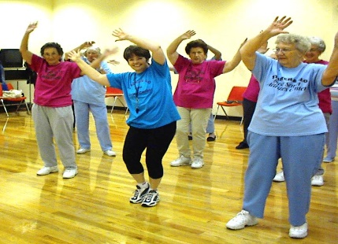
Fall Findings:
- One out of three older adults fall each year, but less than 50% will discuss it with their physicians.
- 20-30% of individuals that fall suffer moderate to severe injuries.
- Falls are the leading cause of both fatal and non-fatal injuries in seniors.
- 35% of brain injuries are caused by falls.
- 50% of seniors who fall have trouble getting up without help.

Fall Symptoms:
- General weakness, dizziness or lightheadedness.

Fall Prevention Strategies:
- Have a regular exercise program.
- Have routine eye exams.
- Check medications on a regular basis to make sure your loved one is not overmedicated or having drowsiness or dizziness.
- Create a safe home environment with proper day and night lighting, sturdy railings, removal of throw rugs and other trip hazards.

When A Fall Happens:
- Contact your loved one's physician and have an assessment to help determine the cause of the fall.
- Give the physician accurate information regarding the fall incident and current medications.
- Discuss with the physician if the fall could be related to other health issues.
- Ask the physician if physical therapy is an option for your loved one.
- Have a family meeting to discuss a care plan to help keep your loved one safe.

If your loved one is struggling at home to care for her/himself and you would like to explore senior care and housing options, please give us a call today. We will be happy to create a personalized care plan for your loved one.

www.APlanForSeniorCare.com Call Us Today (866) 657-0026 info@aplanforseniorcare.com

