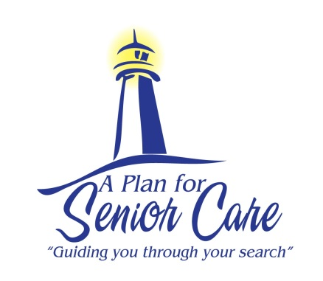
A Plan For Senior Care’s Guide To
Heart Health

According to Centers for Disease Control and Prevention, every year about 720,000 Americans have a heart attack. Of these, 515,000 are a first heart attack and 205,000 happen to people who have already had a heart attack. Use our guide to help your senior loved one keep a healthy heart.
Tips for Maintaining Heart Health:
- Exercise for 30 minutes at least 3-4 times a week
- Quit smoking and reduce the amount of alcohol you drink
- Watch your weight
- Lower high blood pressure and high cholesterol levels
- Keep diabetes under control
- Minimize stress in your senior loved ones life by finding
healthy outlets to relieve stress.
- Eat a heart-healthy diet with a lot of fresh fruits and vegetables. Limit saturated fats, salt, and foods containing cholesterol, like fatty meats.
- Get regular check-ups to monitor health conditions that affect the heart, including high blood pressure, high cholesterol, and diabetes, and make sure they are under control with medication.
Signs of Heart Disease:
- Unable to catch your breath
- Feeling faint, light-headed or weak
- Nausea or vomiting
- Feeling very full or having indigestion
- Unusual pains in the back, shoulders, or neck
- Sweating
- Pain/ Pressure in the chest
- Irregular heartbeat
- Weakness or a sensation of light-headedness
Visit http://www.cdc.gov/heartdisease/ for more information on heart disease

If your loved one is struggling at home to care for her/himself and you would like to explore senior care and housing options, please give us a call today. We will be happy to create a personalized care plan for your loved one.

www.APlanForSeniorCare.com Call Us Today (866) 657-0026 info@aplanforseniorcare.com

