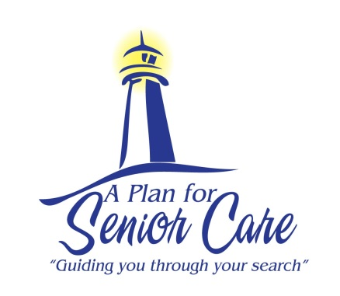
A Plan For Senior Care’s Guide To
Stroke Warning Signs & Prevention

Stroke is the fourth leading cause of deaths in America. The risk for stroke increases at age 55. A stroke happens when a blood vessel that connects to the brain is blocked (ischemic stroke) or bursts (hemorrhagic stroke). Learn the warning signs of a stroke and how to help protect your loved one.

Warning Signs:
- Weakness of the face, arm and leg
- Confusion, trouble speaking and understanding
- Blurry vision
- Dizziness, not able to walk, no coordination
- Sudden and severe headache

How do you know if someone is having a stroke? Think… F.A.S.T.
The National Stroke Foundation recommends the F.A.S.T. test as an easy way to remember the most common signs of stroke. Using the F.A.S.T. test involves asking these simple questions:
Face - Check their face. Has their mouth drooped?
Arms - Can they lift both arms?
Speech - Is their speech slurred? Do they understand you?
Time - Is critical. If you see any of these signs call 911 to seek immediate help

Prevention:
- Stop smoking
- Maintain a healthy blood pressure
- Eat a heart healthy diet. A good resource for diet guidelines is
www.heart.org/HEARTORG/GettingHealthy/NutritionCenter/HealthyEating/The-American-Heart-Associations-Diet-and-Lifestyle-Recommendations_UCM_305855_Article.jsp
- Be active and maintain a healthy weight
- Follow any directions from your doctor about medications
For more information on strokes visit www.strokeassociation.org and www.ocstroke.org which offer support groups to survivors, caregivers, and family members.

If your loved one is struggling at home to care for her/himself and you would like to explore senior care and housing options, please give us a call today. We will be happy to create a personalized care plan for your loved one.

www.APlanForSeniorCare.com Call Us Today (866) 657-0026 info@aplanforseniorcare.com

